### END TO END PROJECT

https://github.com/akshu20791/cicdakshat

launch a 3 ubuntu machines

Ubuntu machines
Create key pair
Allow all traffic
T3.medium
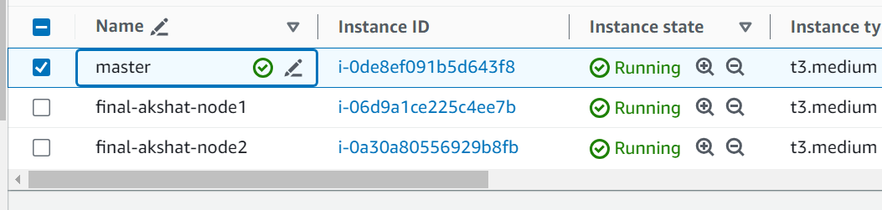

Login to each machine
wget https://raw.githubusercontent.com/akshu20791/Deployment-script/main/jenkins.sh
chmod 777 jenkins.sh
./jenkins.sh

service jenkins start

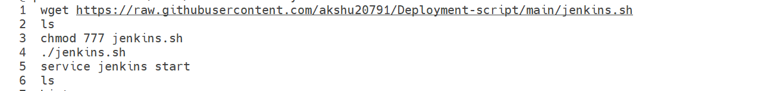

2) 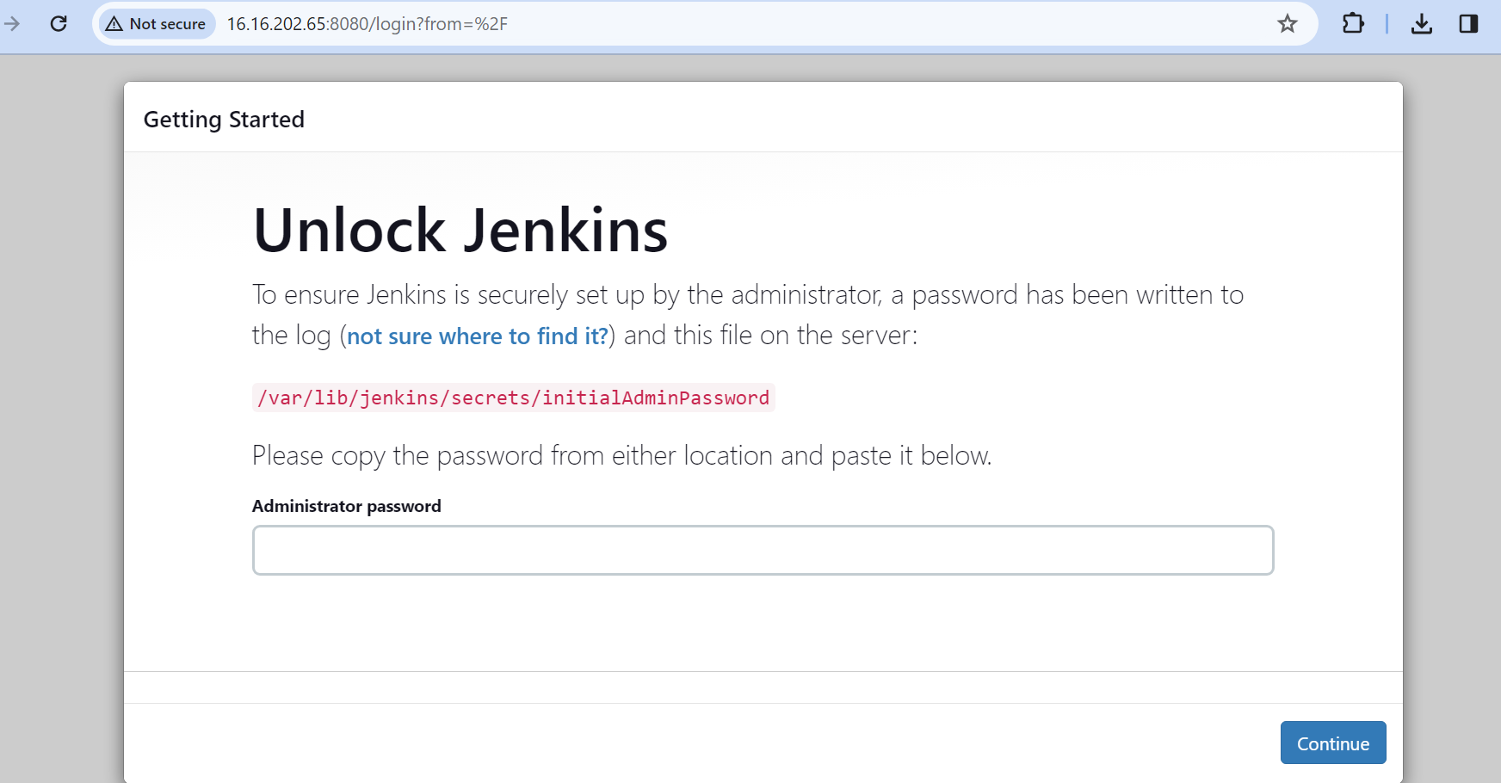

Copy paste this pass in the administrator pass

Get inside Jenkins

Go to manage Jenkins -> Credentials -> Click on global -> + add credentials

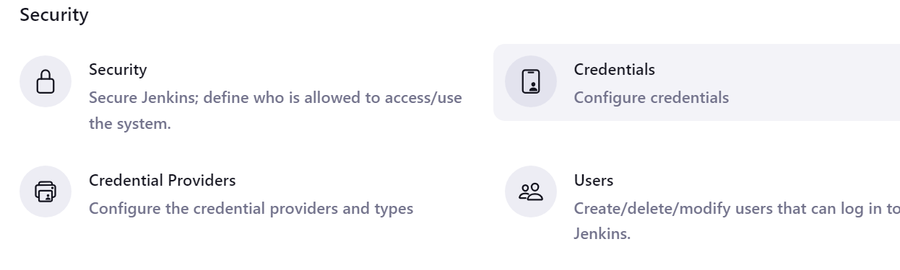

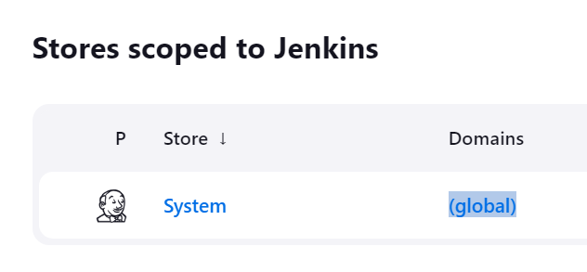

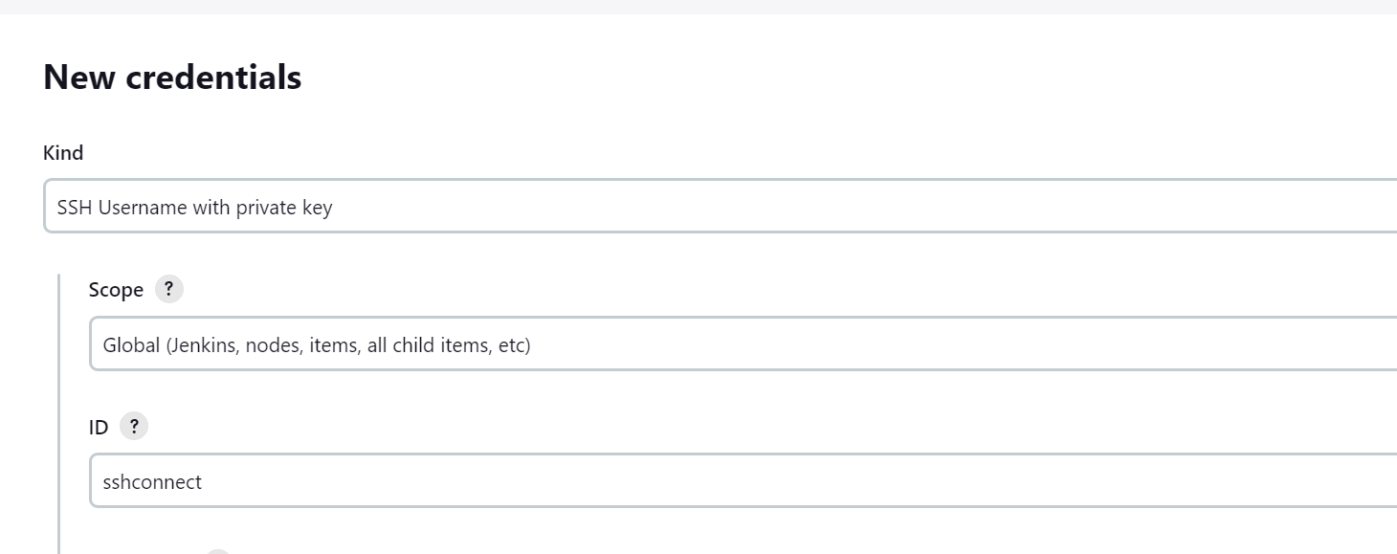

Username : ubuntu (if using linux then use ec2-user)
Click on add
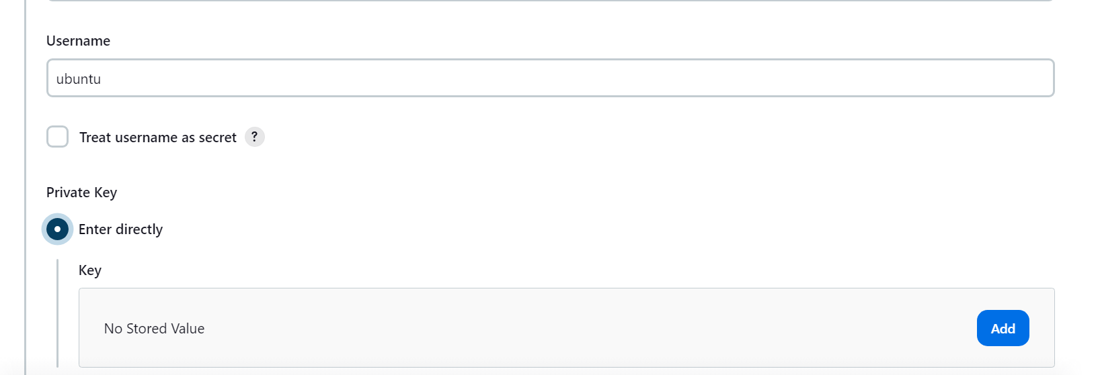

Copy the pem files of your nodes and paste it

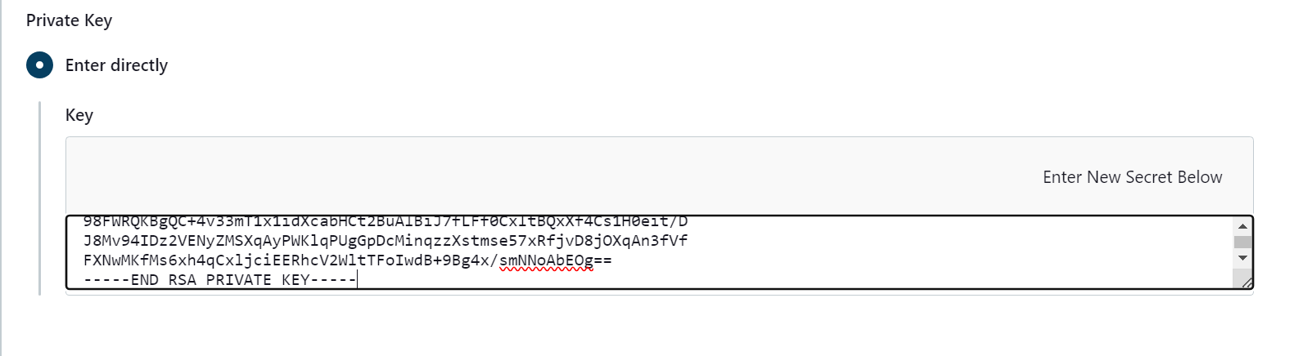

In case the github repo is public
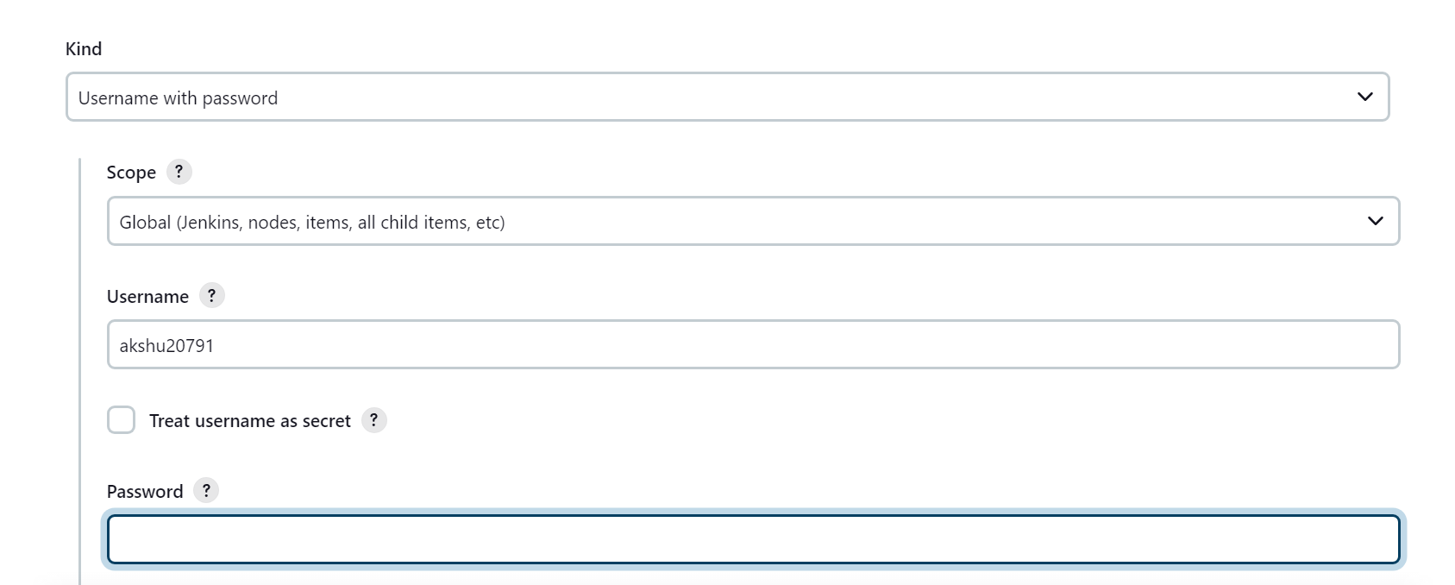

Use pat in password

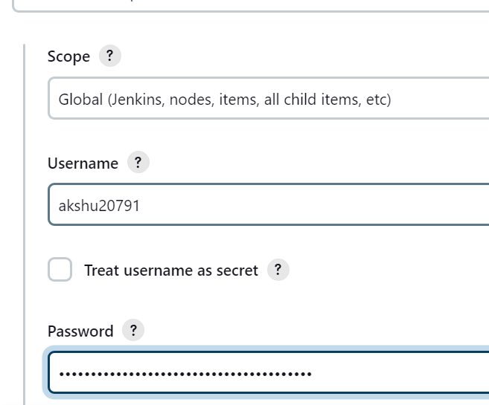

save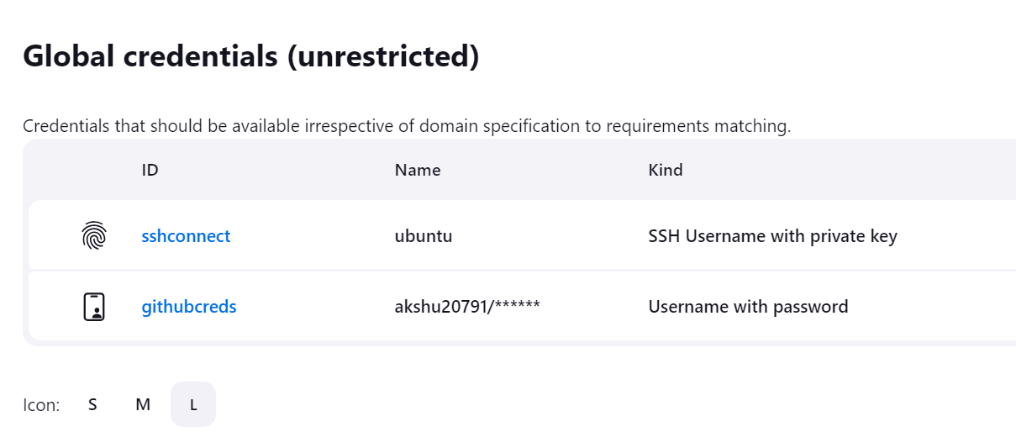

Lets create docker credentials as well

Kind : username and pass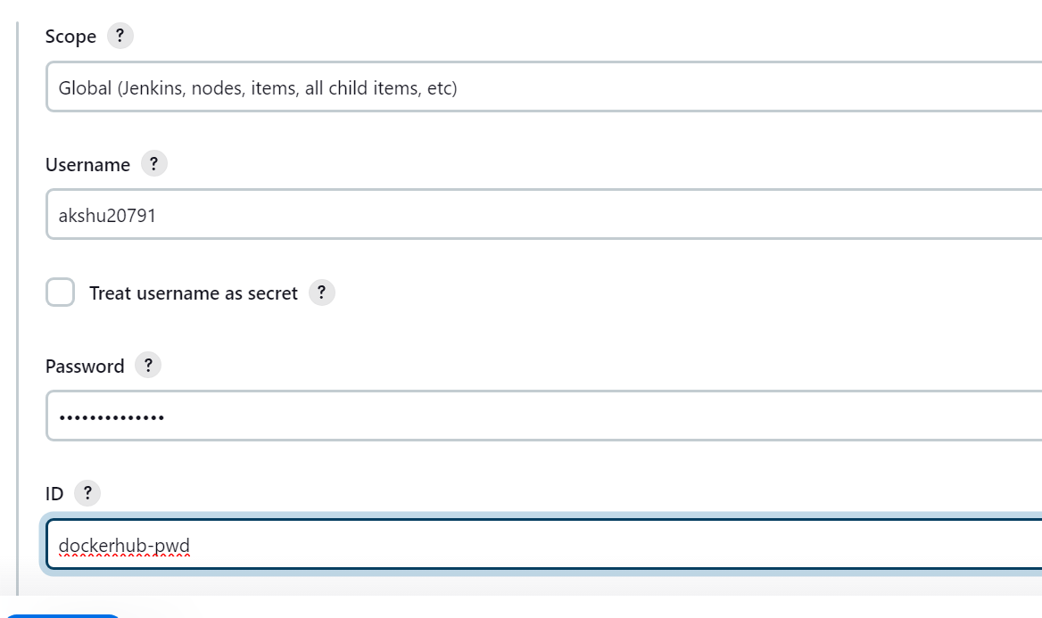
Put dockerhub username and pass

Now lets install kubernetes as well

IN master machine execute:

wget https://raw.githubusercontent.com/akshu20791/Deployment-script/main/k8s-master.sh

chmod 777 k8s-master.sh

./k8s-master.sh

####
now lets install k8s in nodes

wget https://raw.githubusercontent.com/akshu20791/Deployment-script/main/k8s-nodes.sh
chmod 777 k8s-nodes.sh
./k8s-nodes.sh

#####
Go to master machine

## Run Below on Master Node to get join token

kubeadm token create --print-join-command

copy the kubeadm join token from master & ensure to add --cri-socket unix:///var/run/cri-dockerd.sock as below & then run on worker nodes
kubeadm join 172.31.18.218:6443 --cri-socket unix:///var/run/cri-dockerd.sock --token ncomle.kuzlw14pr6shovt8 --discovery-token-ca-cert-hash sha256:6b32f3cd891f804ced97d64eefe9891f20db885a2796b7ba0b6a107d5efb486c

Ex: kubeadm join 10.128.15.231:6443 --cri-socket unix:///var/run/cri-dockerd.sock --token mks3y2.v03tyyru0gy12mbt \
--discovery-token-ca-cert-hash sha256:3de23d42c7002be0893339fbe558ee75e14399e11f22e3f0b34351077b7c4b56

Now lets create pipeline
Click on new item
Select pipeline

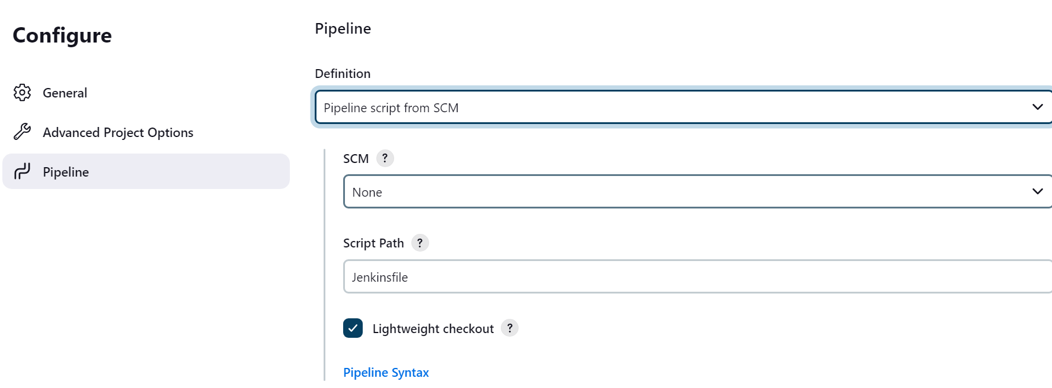
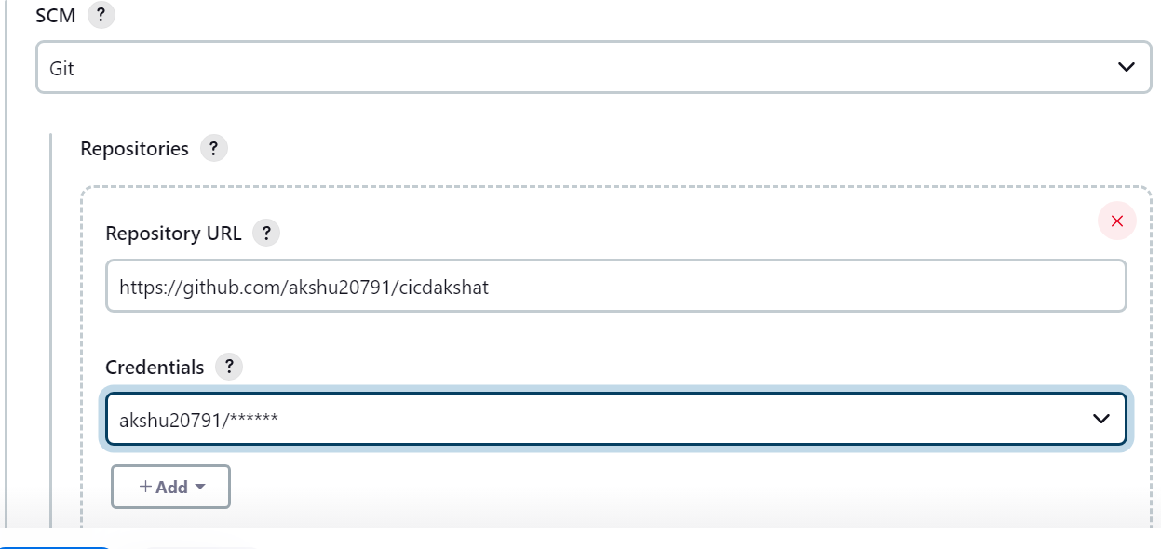

Save
Go to github.com

Update Jenkinsfile as per your requirement
################

Go to Jenkins -> install plugins
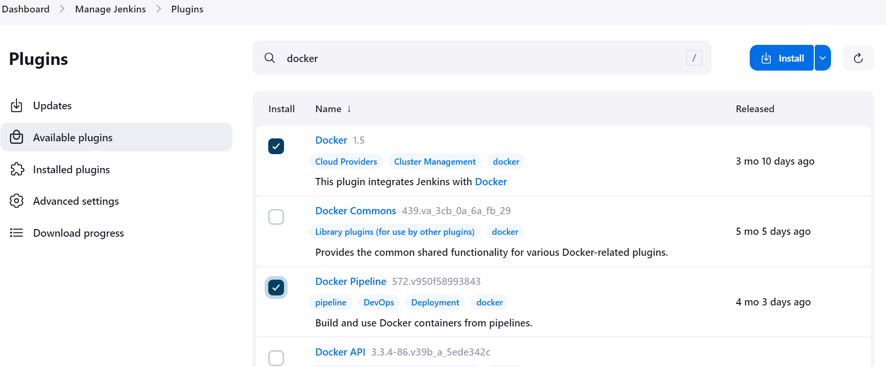

We will also install k8s plugin
Download the file
https://github.com/akshu20791/cicdakshat/blob/master/kubernetes-cd.hpi
in Jenkins -> manage plugins -> plugins -> advance settings
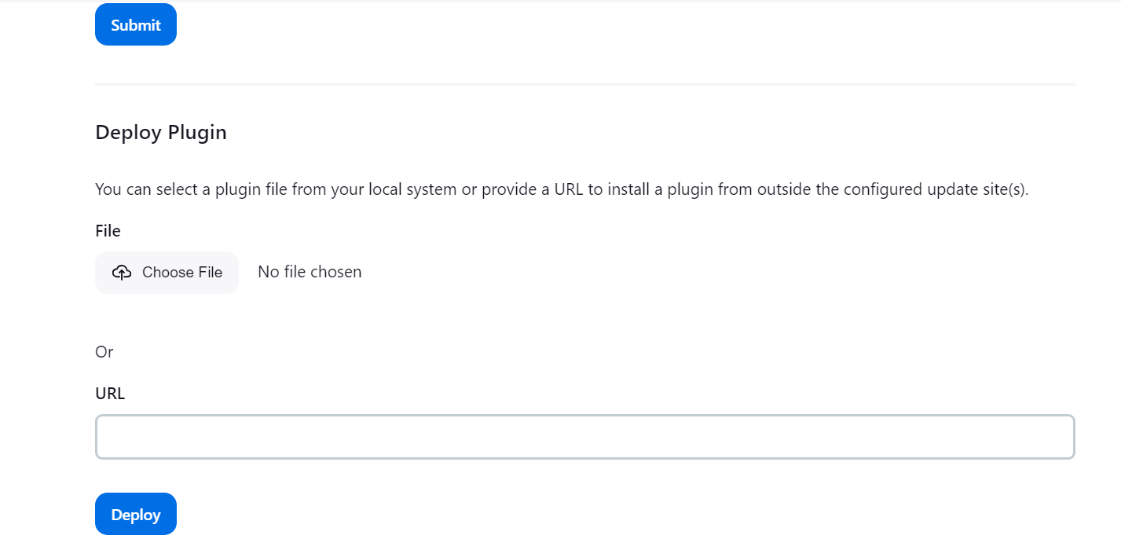
Upload the plugin downloaded
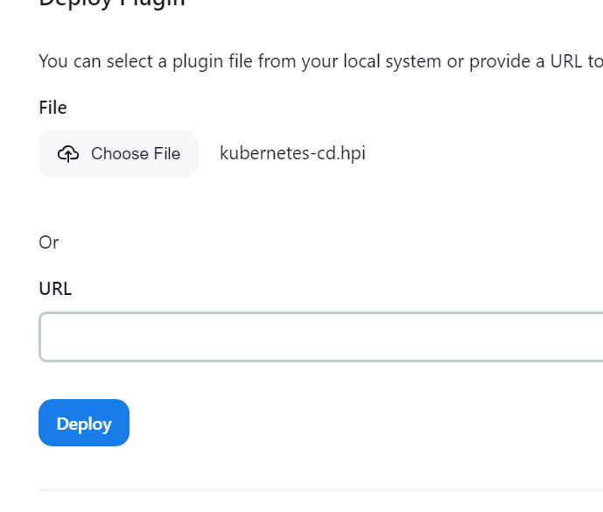
Deploy
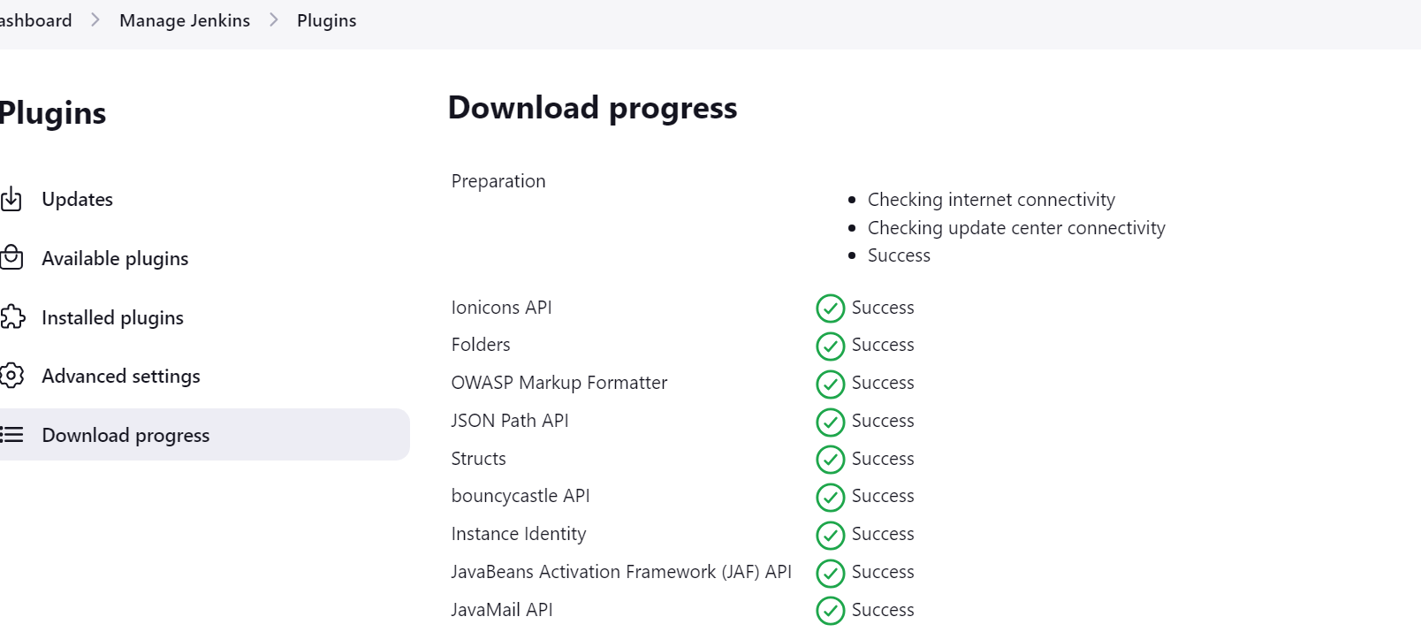

Go back to Jenkins pipeline
When you execute you wil get docker permission issues
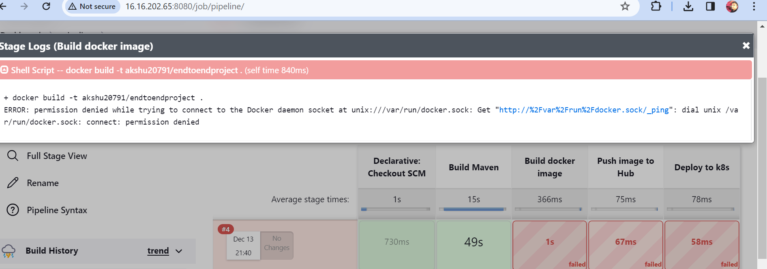

Go to machine and execute:
sudo usermod -aG docker jenkins

service jenkins restart (impotant step)

Now you will see it will build and push the image to docker hub
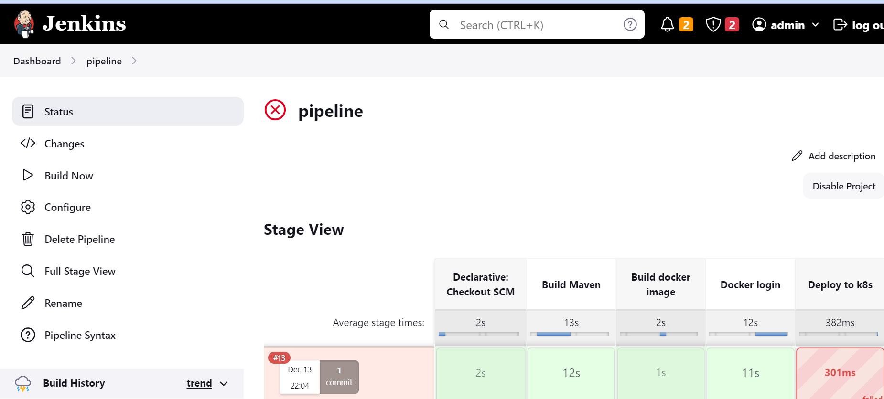

Lets configure kubeconfig

We need to generate the code
Go to your pipeline
Scroll down and click on pipeline syntax
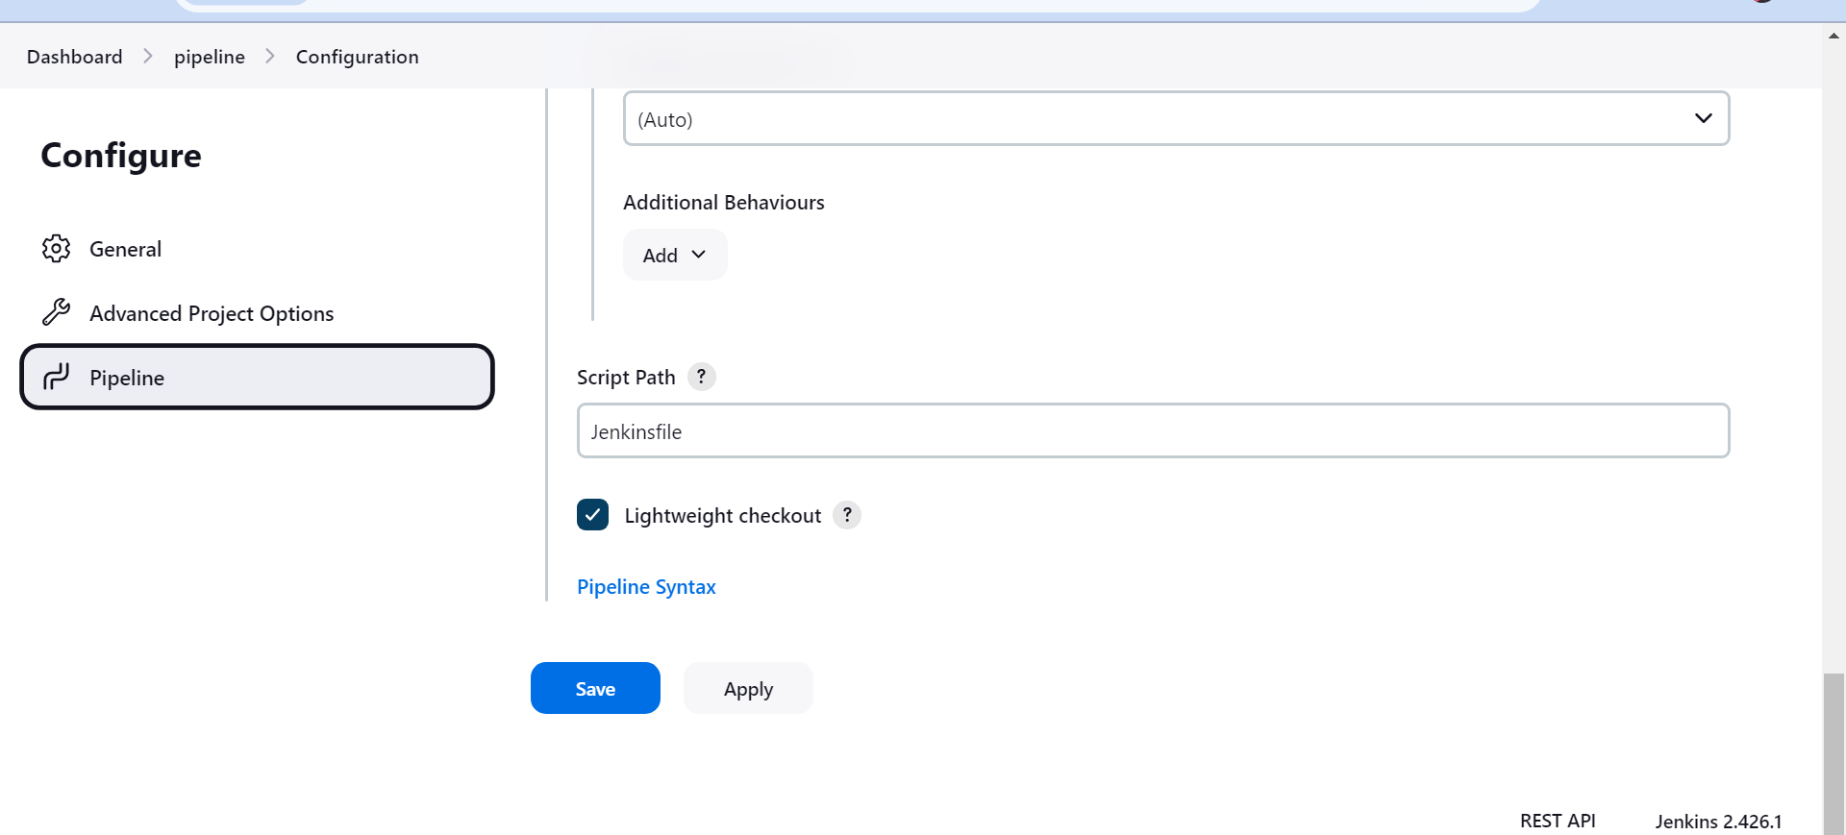

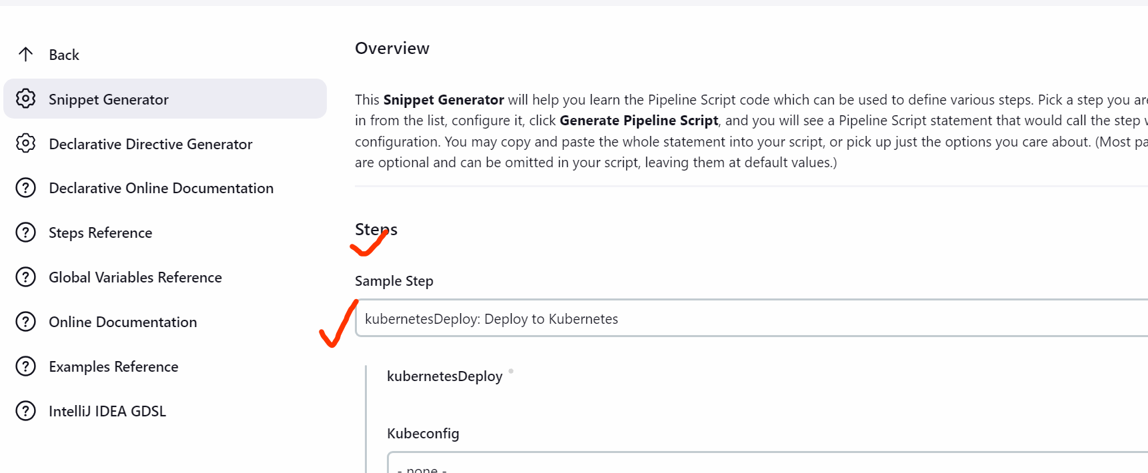

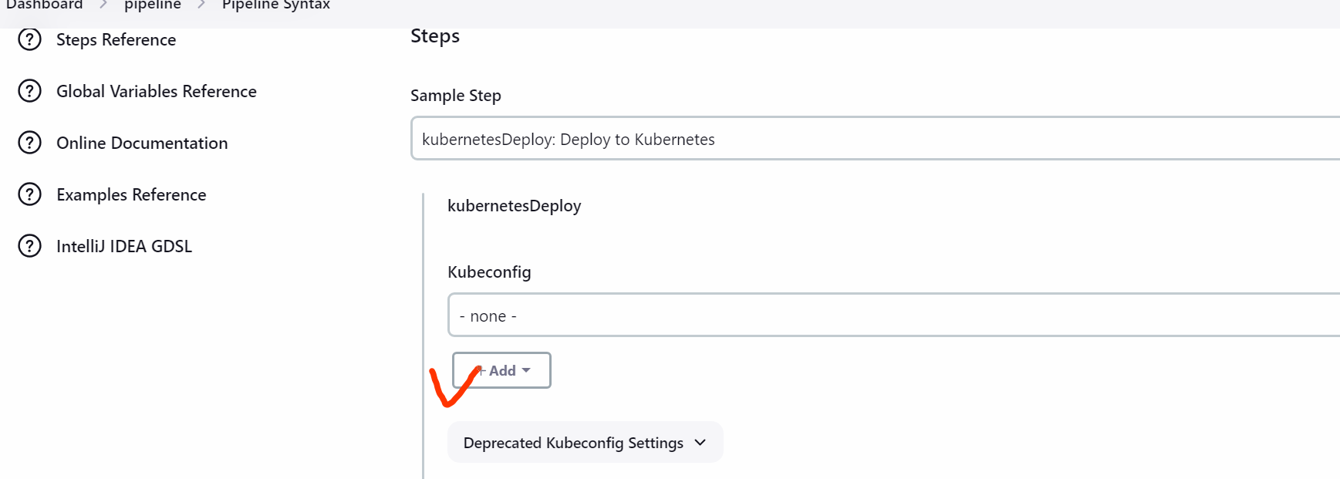

Kind: Kubernetes configuration

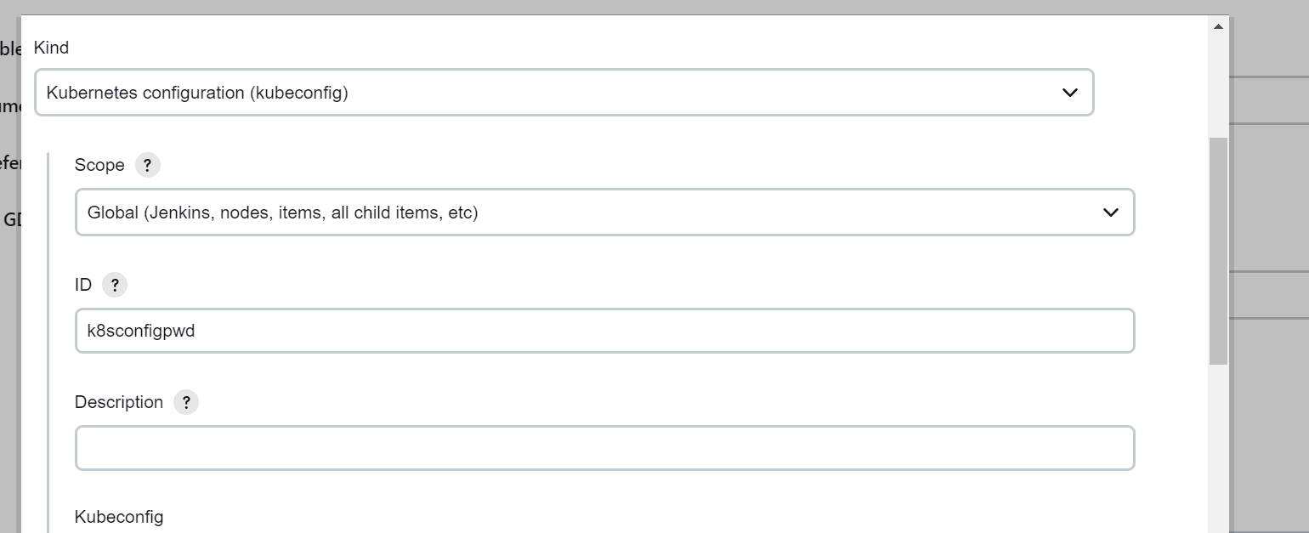

Go to master
cd ~
ls -la
cd .kube
ls
cat config
copy the o/p of this file and paste it in Jenkins

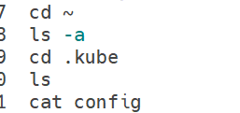

Paste here
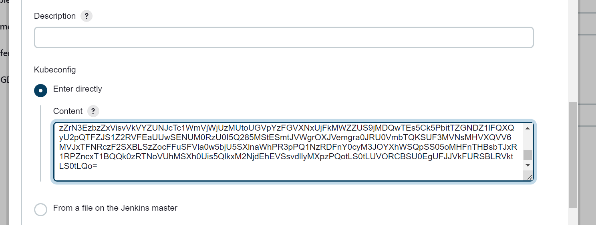

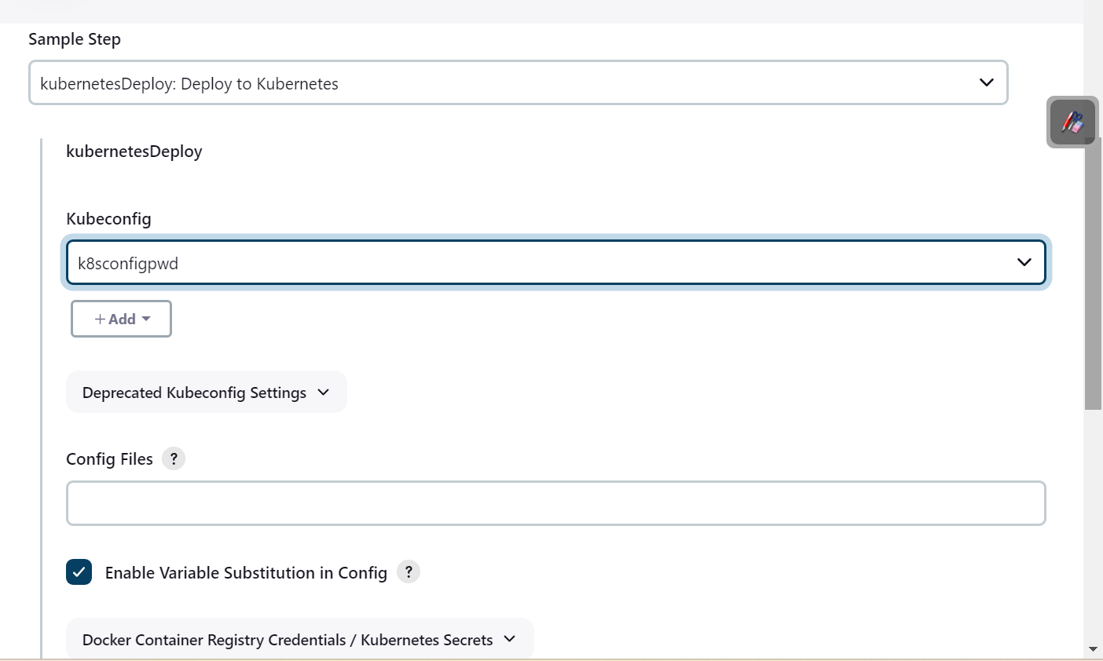

Generate pipeline script
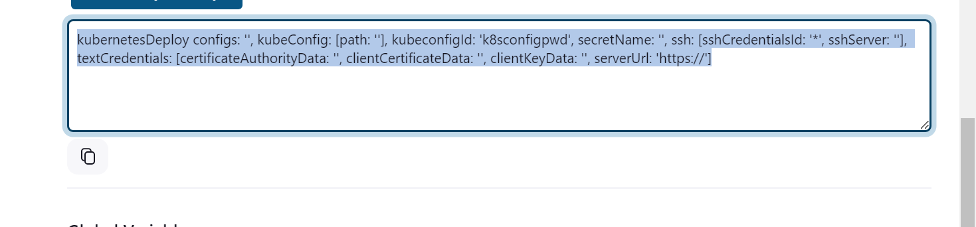
Now you can remove the not required content
You can also remove this kubeConfig: [path: ]
Update in Jenkins file

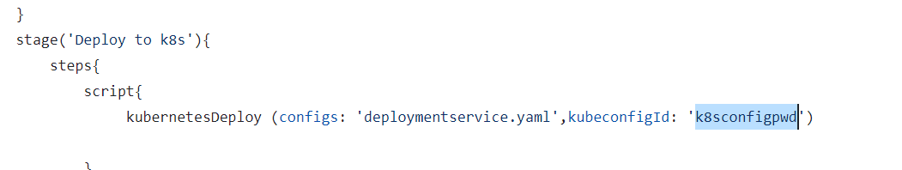

##excute the pipeline

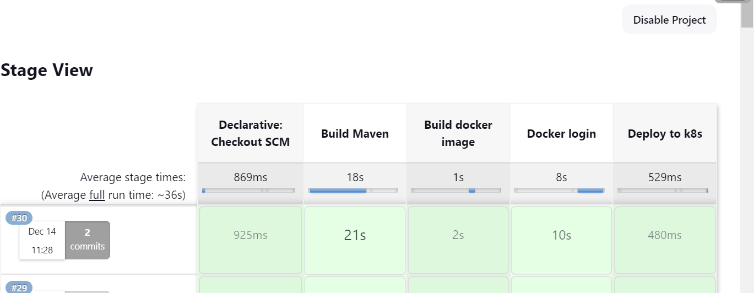

Now
Go back to master:

sudo su
kubectl get pods
copy one pod
kubectl logs <pod name>
kubectl get svc

Copy the port number
And cop public ip :port (in our case publicip:31144)

